Name:
ME 6710, Exam 1 July 7, 2017
Exam Rules: Treat as a normal exam of your own work only. Self-proctor this exam. You are allowed 2.5 hours maximum to work on the exam. This time period can occur in two sittings if needed. Once you begin the exam, you cannot resume “study” other than the time allowed for the exam. This is an open-book, open notes exam.
# 1: (10%) Matching:
 | Match
1) Conservation of momentum |  | a) 6
2) Force equals the time derivative of momentum |  | b)The Farm
3) For every action there is an equal and opposite reaction |  | c) Newton’s Second law
4) In Newton’s equations, the acceleration must be relative to this type of reference frame |  | d) Newton’s third law
5) Rotation matrices are combined through _____. |  | e) inertial or fixed
6) What the duke boys were always trying to save |  | f) Newton’s first law
7) Number of generalized coordinates needed to describe the motion of a rigid body in space |  | g) multiplication
8) (True or False) Watching the Dukes of Hazzard can teach you a lot about dynamics.
9) (True or False) Lagrange’s equations eliminate all workless, constraint forces
10) (True or False) Orientation can be described as a vector

# 2: (5%): Write Newton’s equations in vector form

# 3: (5%) Write Euler’s equations in vector form

#4 (5% ) List three different ways to analyze differential equations

#5) (15%) Derive Euler’s angular equations for a 1-2-3 φ, θ, ψ rotation ( an aerospace standard rotation). i.e., find relationships between the time derivatives of φ, θ, ψ and ω₁, ω₂, ω₃,

#6 (60%) Here’s Kevin at Dollywood studying dynamics. For this problem, assume a rotation of phi, phi_dot (constant) about the vertical axis, an angle of beta (constant) for the top wheel (pink), and an angle of theta (varying theta_dot, theta_ddot) rotating about an axis lying in the plane of the top wheel.
Kevin is a lumped mass m, on fixed-length chain l (assume more of a rigid link than chain), top radius is R and height of tower is h.
Part 1 (30%) Find the velocity and angular acceleration of Kevin, and write in a frame attached to the body, with b2 pointing down along the chain.
Part 2 (30%) Write the equations of motion and the reactions at the bearing at top of the link for mass m. Use Newton Euler equations.
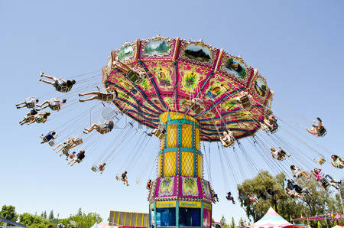 l
R
h
θ
β
φ
m
l

