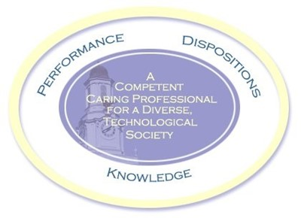

**Schedule: Handgun Tuesday**

TOPICS TO BE COVERED*:

01 / 21 / 25       1          Orientation. at TTU in the MG room TBA

01 / 28              2          Tennessee laws (by law enforcement personnel).  Bring two questions on you and handguns in Tennessee for discussion.

02 / 04              3        Gun familiarization. **This and the rest of the classes will be at The Bend of the River.** 10 miles north of the campus on highway 136 (north Washington Ave. Out past the new high school). If you pass Hardy’s Chapel Fire Dept., STOP and turn around. You have gone 2 miles too far. Map to Bend of the River. ** Chapter 1, page 3, Chapter 20 page 183.

02 / 11           4          Alternatives to shooting – live fire. ** Chapter 5

02 / 18               5          1/3 term exam

03 / 25               6          Cleaning and reloading – And live fire. ** Appendix A page 203

04 / 04               7          Ammunition -live fire. ** Chapter 21 page 189

04 / 11               8        Introduction to basic competitive shooting. ** Page 111

**03 / 17 to 21             SPRING BREAK   No Class**

03 / 25             9        1/3 term exam

04 / 01               10       Fundamentals of shooting Chapter 7 page 37 ,   Review – live fire

04 / 08               11      How to carry concealed and why

04 / 15               12      Live fire Big Guns

04 / 22               13       Shoot state course of fire.

04 / 29 14 1/3 term exam (final for this class).

*Class Schedule may change depending on weather, etc.