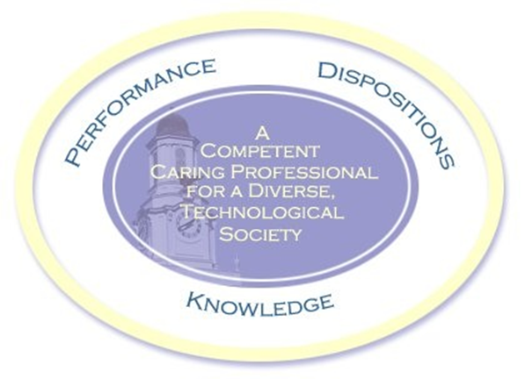

Schedule: Handgun Monday 001
TOPICS TO BE COVERED*:
01 / 22 / 24 1 Orientation. at TTU in the MG room 112
01 / 29 2 Tennessee laws (by law enforcement personnel). Bring two questions on you and handguns in Tennessee for discussion.
02 / 05 3 Gun familiarization. This and the rest of the classes will be at The Bend of the River. 1 0 miles north of the campus on highway 136 (north Washington Ave. Out past the new high school). If you pass Hardy’s Chapel Fire Dept., STOP and turn around. You have gone 2 miles too far. Map to Bend of the River. ** Chapter 1, page 3, Chapter 20 page 183.
02 / 12 4 Alternatives to shooting – live fire. ** Chapter 5
02 / 19 5 1/3 term exam
02 / 26 6 Cleaning and reloading – And live fire. ** Appendix A page 203
03 / 04 7 Ammunition -live fire. ** Chapter 21 page 189
03 / 11 to 15 SPRING BREAK No Class
03 / 18 8 Introduction to basic competitive shooting. ** Page 111
03 / 25 9 1/3 term exam.
04 / 01 10 Fundamentals of shooting Chapter 7 page 37 , Review – live fire
04 / 08 11 Review Live fire Big Guns
04 / 15 12 Shoot state course of fire.
04 / 22 13 1/3 term exam (final for this class).
*Class Schedule may change depending on weather, etc.

