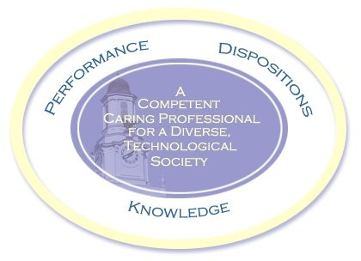

Schedule: Rifle Thursday
01 /12/ 23 1 Orientation. at TTU in the MG room 107
All other classes to be at Bend of the River range. Go north on Hwy TN 136 for 10 miles. Range will be on the left just after crossing into Overton County the second time. If you pass Hardy’s Chapel Fire Dept., STOP and turn around. You have gone 2 miles too far.
01 / 19 2 Prone position and range procedures – live fire. ** page 39 & page 90
01 / 26 3 Shoot prone.
02 / 02 4 Lecture on terms, and rules for smallbore rifle shooting. ** Chapter 1 page 3.
02 / 09 5 Cleaning, reloading 1/3 term exam ** Chapter 4 page 47
02 / 16 6 Sitting position – shoot sitting.
02 / 23 7 Shoot sitting.
03 / 02 8 Kneeling position – shoot kneeling. ** Chapter 3 page 93
03 / 09 9 Shoot kneeling

03 / 13 - 17 SPRI NG BREAK NO CLASSES
03 / 23 10 1/3 term exam
03 / 30 11 Sanding position ** Chapter 3 page 81
04 / 13 12 Sanding position
04 / 20 13 CMP qualifying ** Shoot 4 shot/bull prone
04 / 27 14 Final Exam at Bend of the River
*Class Schedule may change depending on weather, etc.

